Woolgrove Well-Being Newsletter
May 2020
Mental Health Awareness Week Monday 18th to 24th May 2020
Dear Parents/Carers and Staff
I do hope you and your families are well. We know at this stage of being at home during lockdown that everyone is feeling the effects of this prolonged period of time. Whilst we may be putting on a “brave face” many of us are getting tired and fed up of the situation. It is hard as everyone’s 'window of tolerance' is likely narrower than usual and as a result you might feel more reactive or less reactive than usual, especially when it may feel you don't have a lot of control or choice at the moment. It’s the same for all of us: parents/carers, pupils and staff.
Mental Health Awareness week: Monday 18th to 24th May 2020
This week is Mental Health awareness week – a time for all of us to stop and re focus on the important things in life. This year’s theme is KINDNESS. We all have so much going on in our lives including competing strains and stresses – not to mention the current coronavirus pandemic. This can see kindness pushed to one side, in favour of what is urgent or trending now. It can be easy to signal kindness by posting online and following a trend, but harder to commit to kindness in our daily words and actions. But if we take the time to be kind to other people, we can reap the emotional benefits. It can really make a difference and especially for people who are vulnerable or struggling.
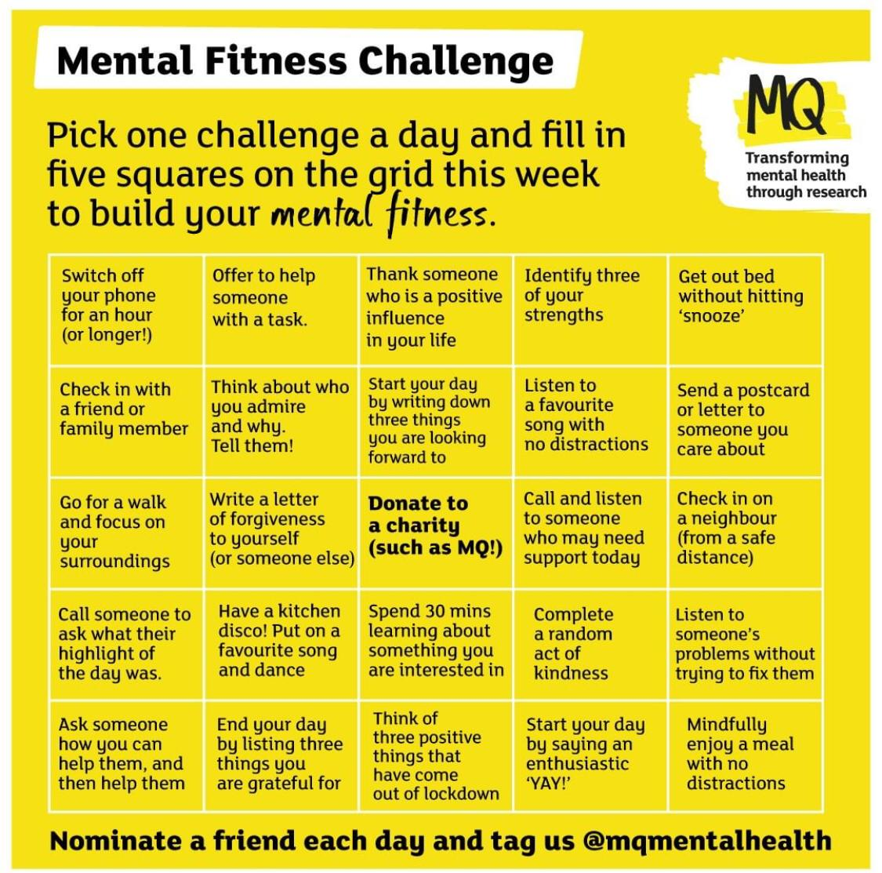
Self compassion – YOU are doing a BRILLIANT job!
MQ Mental Health has produced this Mental Health Fitness Challenge – a great way to spend the week focusing on being kind to yourself and others!
https://www.mqmentalhealth.org/posts/mental-health-awareness-week-2020
Woolgrove School would like to say a heartfelt thank you to all of our parents, carers, pupils and staff. Whether you’re a parent/carer balancing the demands of work and home schooling, a member of our staff working hard at home or at school or a pupil – you are all doing an amazing job!
We have been busy making calls and checking in with families and it has been lovely to make contact and catch up with you all.
Please try and take some time this week (even if it’s just a few moments) to consider the times that have gone really well at home and what it was you did that helped facilitate that.
You may feel you just don't have time to do anything for yourself at the moment but it’s so important to stop, acknowledge the amazing job you are doing and take some time for yourself.
Here is an example of a simple 3 minute 'mindful meditation' exercise on youtube.
https://www.youtube.com/watch?v=SEfs5TJZ6Nk there are many apps and other examples of this on youtube which can be used.
We are here to help!
Woolgrove School is open and our staff are here and ready to help – whether it’s just for a chat or to get some advice or signposting to local services please do give us a call.
Check out the Mental Health section of our website for lots of ideas to support your families Well-Being. There are also videos created by Emma, our Pastoral Support Worker, which may be of help at this time.
https://woolgrove.herts.sch.uk/mental-health/
Preparing children for returning to school
Most children are currently at home full-time and others are attending on a vastly reduced and different timetable. Whilst this may change over the next few weeks with the potential for more children to attend school, many will be finding the transition of coming back worrying and difficult, particularly those of whom may not start back until September.
Here are some ideas from Louise Bomber, Strategic Attachment Lead Teacher & Therapist, on how to support pupils with the idea of returning to school when the time is right.
- Keeping connection with school: Visit our website, talk about school, take a drive past or go for a walk along the Greenway around our school once a week. Seeing school helps them to remember it is still there and it hasn't disappeared. Initiate conversation about it. Share and create memories together.
- Start to prepare transitional objects or objects of reference: consider transitional objects which also represent something of the time you have spent together at home over the quarantine period e.g a photo book or decorating water bottles, the idea being that parent and child both have the same drink bottle. Another suggestion is to make family friendship bracelets so when it comes to returning to school, your child and you (and others in the family) can wear them.

5 Steps to Well-Being :
Evidence suggests there are 5 steps you can take to improve your mental health and wellbeing. Trying these things could help you feel more positive and able to get the most out of life.
The NHS have published a guide to the 5 steps to wellbeing with lots of suggestions on how to action each step:
https://www.nhs.uk/Conditions/stress-anxiety-depression/Pages/improve-mental-wellbeing.aspx:

If you give them a try, you may feel happier, more positive and able to get the most from life.
- Connect – connect with the people around you: your family, friends, colleagues and neighbours. Spend time developing these relationships. Learn more in Connect for mental wellbeing.
- Be active – you don't have to go to the gym. Take a walk, go cycling or play a game of football. Find an activity that you enjoy and make it a part of your life. Learn more in Get active for mental wellbeing.
- Keep learning – learning new skills can give you a sense of achievement and a new confidence. So why not sign up for that cooking course, start learning to play a musical instrument, or figure out how to fix your bike? Find out more in Learn for mental wellbeing.
- Give to others – even the smallest act can count, whether it's a smile, a thank you or a kind word. Larger acts, such as volunteering at your local community centre, can improve your mental wellbeing and help you build new social networks. Learn more in Give for mental wellbeing.
- Be mindful – be more aware of the present moment, including your thoughts and feelings, your body and the world around you. Some people call this awareness "mindfulness". It can positively change the way you feel about life and how you approach challenges. Learn more in Mindfulness for mental wellbeing.

Emma Goddard (our Pastoral Support Worker) has also created a short video guide to the 5 steps along with simple activities that you might like to try at home. This video can be found on the Mental Health section of our school website. https://woolgrove.herts.sch.uk/mental-health/

So please do take the time this week to give some of these ideas a try.

All of you take care.
With very best wishes from the

Woolgrove Team

