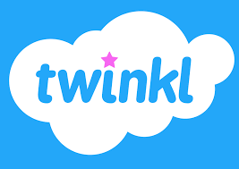
Twinkl parents and home learning page
https://www.twinkl.co.uk/resources/parents
https://www.twinkl.co.uk/home-learning-hub
Sign up for free month
Code: CVDTWINKLHELPS

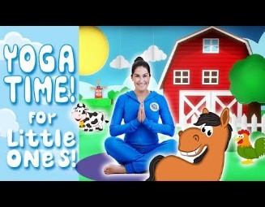
Cosmic Kids Yoga
www.youtube.com/user/CosmicKidsYoga/Videos

Phonics Play – free access
https://new.phonicsplay.co.uk/
Username: march20
Password: home

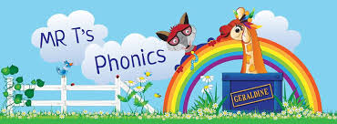
Mr Thorne Does Phonics Videos https://www.youtube.com/watch?v=vMEvxTGvi4c&list=PLqh11DN6jmbCsIPschffPaxvCdS9d6qPN
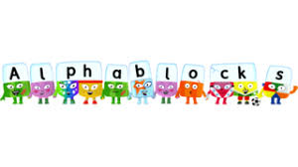

Cbeebies Alphablocks
www.bbc.co.uk/cbeebies/shows/alphablocks

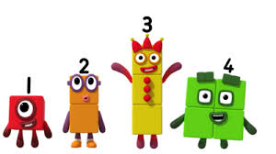

Cbeebies Numberblocks
www.bbc.co.uk/cbeebies/shows/numberblocks

The Communication Trust – Resources for Parents
http://www.thecommunicationtrust.org.uk/resources/resources/

TTS – free downloadable Early Years Home Learning Pack
https://www.tts-group.co.uk/home+learning+activities.html

Tate Kids
https://www.tate.org.uk/kids/

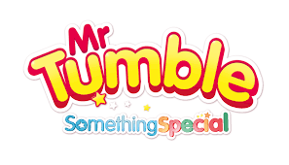
Mr Tumble Official You Tube Channel
https://www.youtube.com/channel/UCynLtJ9E2c34bui4ON0ovGw

The Wiggles You Tube Channel
https://www.youtube.com/channel/UC5vVe2R4ucoMzJP53o38Yaw

12 Live Zoo Webcams
https://www.countryliving.com/uk/wildlife/countryside/g31784857/live-animal-webcam-zoo/

EPIC Early Years Facebook Page – 1 activity idea per day

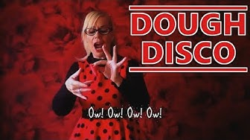

https://www.youtube.com/results?search_query=dough+disco

CBeebies – Things to do at home
https://www.bbc.co.uk/cbeebies/grownups/things-to-do-indoors-with-your-children?collection=have-fun-at-home

