Early Years VI Ideas – getting siblings involved
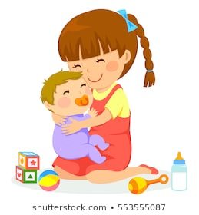
Hello and welcome to our Early Years newsletters that we’ll be producing to try and give you ideas about how to keep your little ones entertained. A big issue, I’m sure all of those with children of different ages are experiencing, is how to keep the children entertained together and activities that older siblings can do along with their younger siblings.
Of course, you don’t need siblings – these work just as well with mum and dad.
Games to Play
- Blowing bubbles – everybody loves bubbles. Get older siblings to blow bubbles in different directions, blow them slowly and above their head or down low. If your little one is big enough – can they catch them, stamp them.
- Singing songs – time to crack out the ‘row rows’. Who doesn’t like a song? See how many big sib can remember. Can they teach the actions?
- Peekaboo – a classic. And their little sibling is super keen to look at their heroes (e.g. big sib). Big sib can hide behind their hands, a folder or put a shirt/cloth over their heads – for added hilarity, little sib may like to pull it off. Extend the game: Hide and seek – can big sib hide behind chairs? On the ground, behind the curtain? – This is great for visual development for little ones not moving (even better if little sib can chase them).
- Hiding a toy – like peekaboo but with a teddy. Can we hide and can we find? Really useful for little ones who are learning to move to get what they want.
- Water play – who doesn’t love splashing around? You can use washing up bowls, roasting dishes or anything that holds water. Use plastic cups and spoons for pouring or you could give babies a bath. If your little one isn’t so keen on water yet – you could just start with paddling. Or why not paint the fence (bucket of water and some big paint Brushes).

Things to make
1. Dark den – den making is a favourite activity, but you can combine this with making it a dark den for to play in with light toys. Clothes airers, chairs and old duvet covers are proper pro-materials, but you can start with some umbrellas and blankets for a less mess alternative.
2. Treasure basket – your little ones are likely to love feeling different textures and objects. How about getting big sib involved in putting together a treasure basket (it’s also a mini science lesson for them). Explore the house to find objects that are: soft, smooth, furry, hard, rough, round, squishy, make a cool noise, natural, man-made(great things for a treasure basket incl: pegs, plastic children’s cutlery, different styles of balls e.g. spikey, round (not too small), beads, squishy toys, small furry toy, mum’s old scarf, shells, pine cones - disinfected) NB: all objects should be checked to ensure they are safe for little ones and, of course, they will need adult supervision while playing with them.
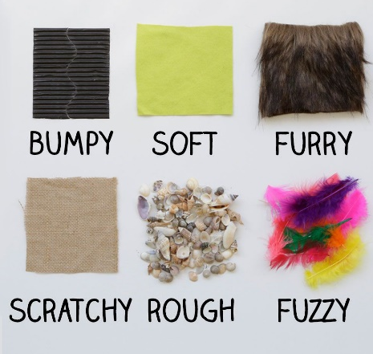
3. Texture board - Older big sib’s may like to make a texture board for the little sibs – time to recycle that ‘lovely’ lacey and taffeta dress Aunt Maud bought for Christmas. Any textures (can be paper, bubble wrap, corrugated cardboard or your old jumper), cut up different shapes and stick onto a board (Cut up cardboard box will do the trick). Of course, a glue gun makes this super easy, however double sided sticky tape works well and is less messy or you can go for PVA glue (it will take longer to dry). Try to cover as much of the board as possible.
4. Creating tactile pictures: there are lots of arts and crafts that you can do however if you have an arty big sib, why don’t they draw the outline or prepare the resources for their little sib to have a go at. Maybe they can draw shapes or pictures e.g. face, fish or house outline and cut different types of paper up that can be stuck on to make a mosaic. If you haven’t run out, you could incorporate some lentils or pasta shapes to make it extra textured. If big sib is still quite small, this might be a good activity to do together – just make sure to cover all surfaces!!

We welcome any feedback about this newsletter, or any queries you may have. Simply get in touch with your child’s Early Years Specialist and/or Specialist Advisory Teacher for VI via email.
Best wishes from everyone in the Vision Impairment Team.

